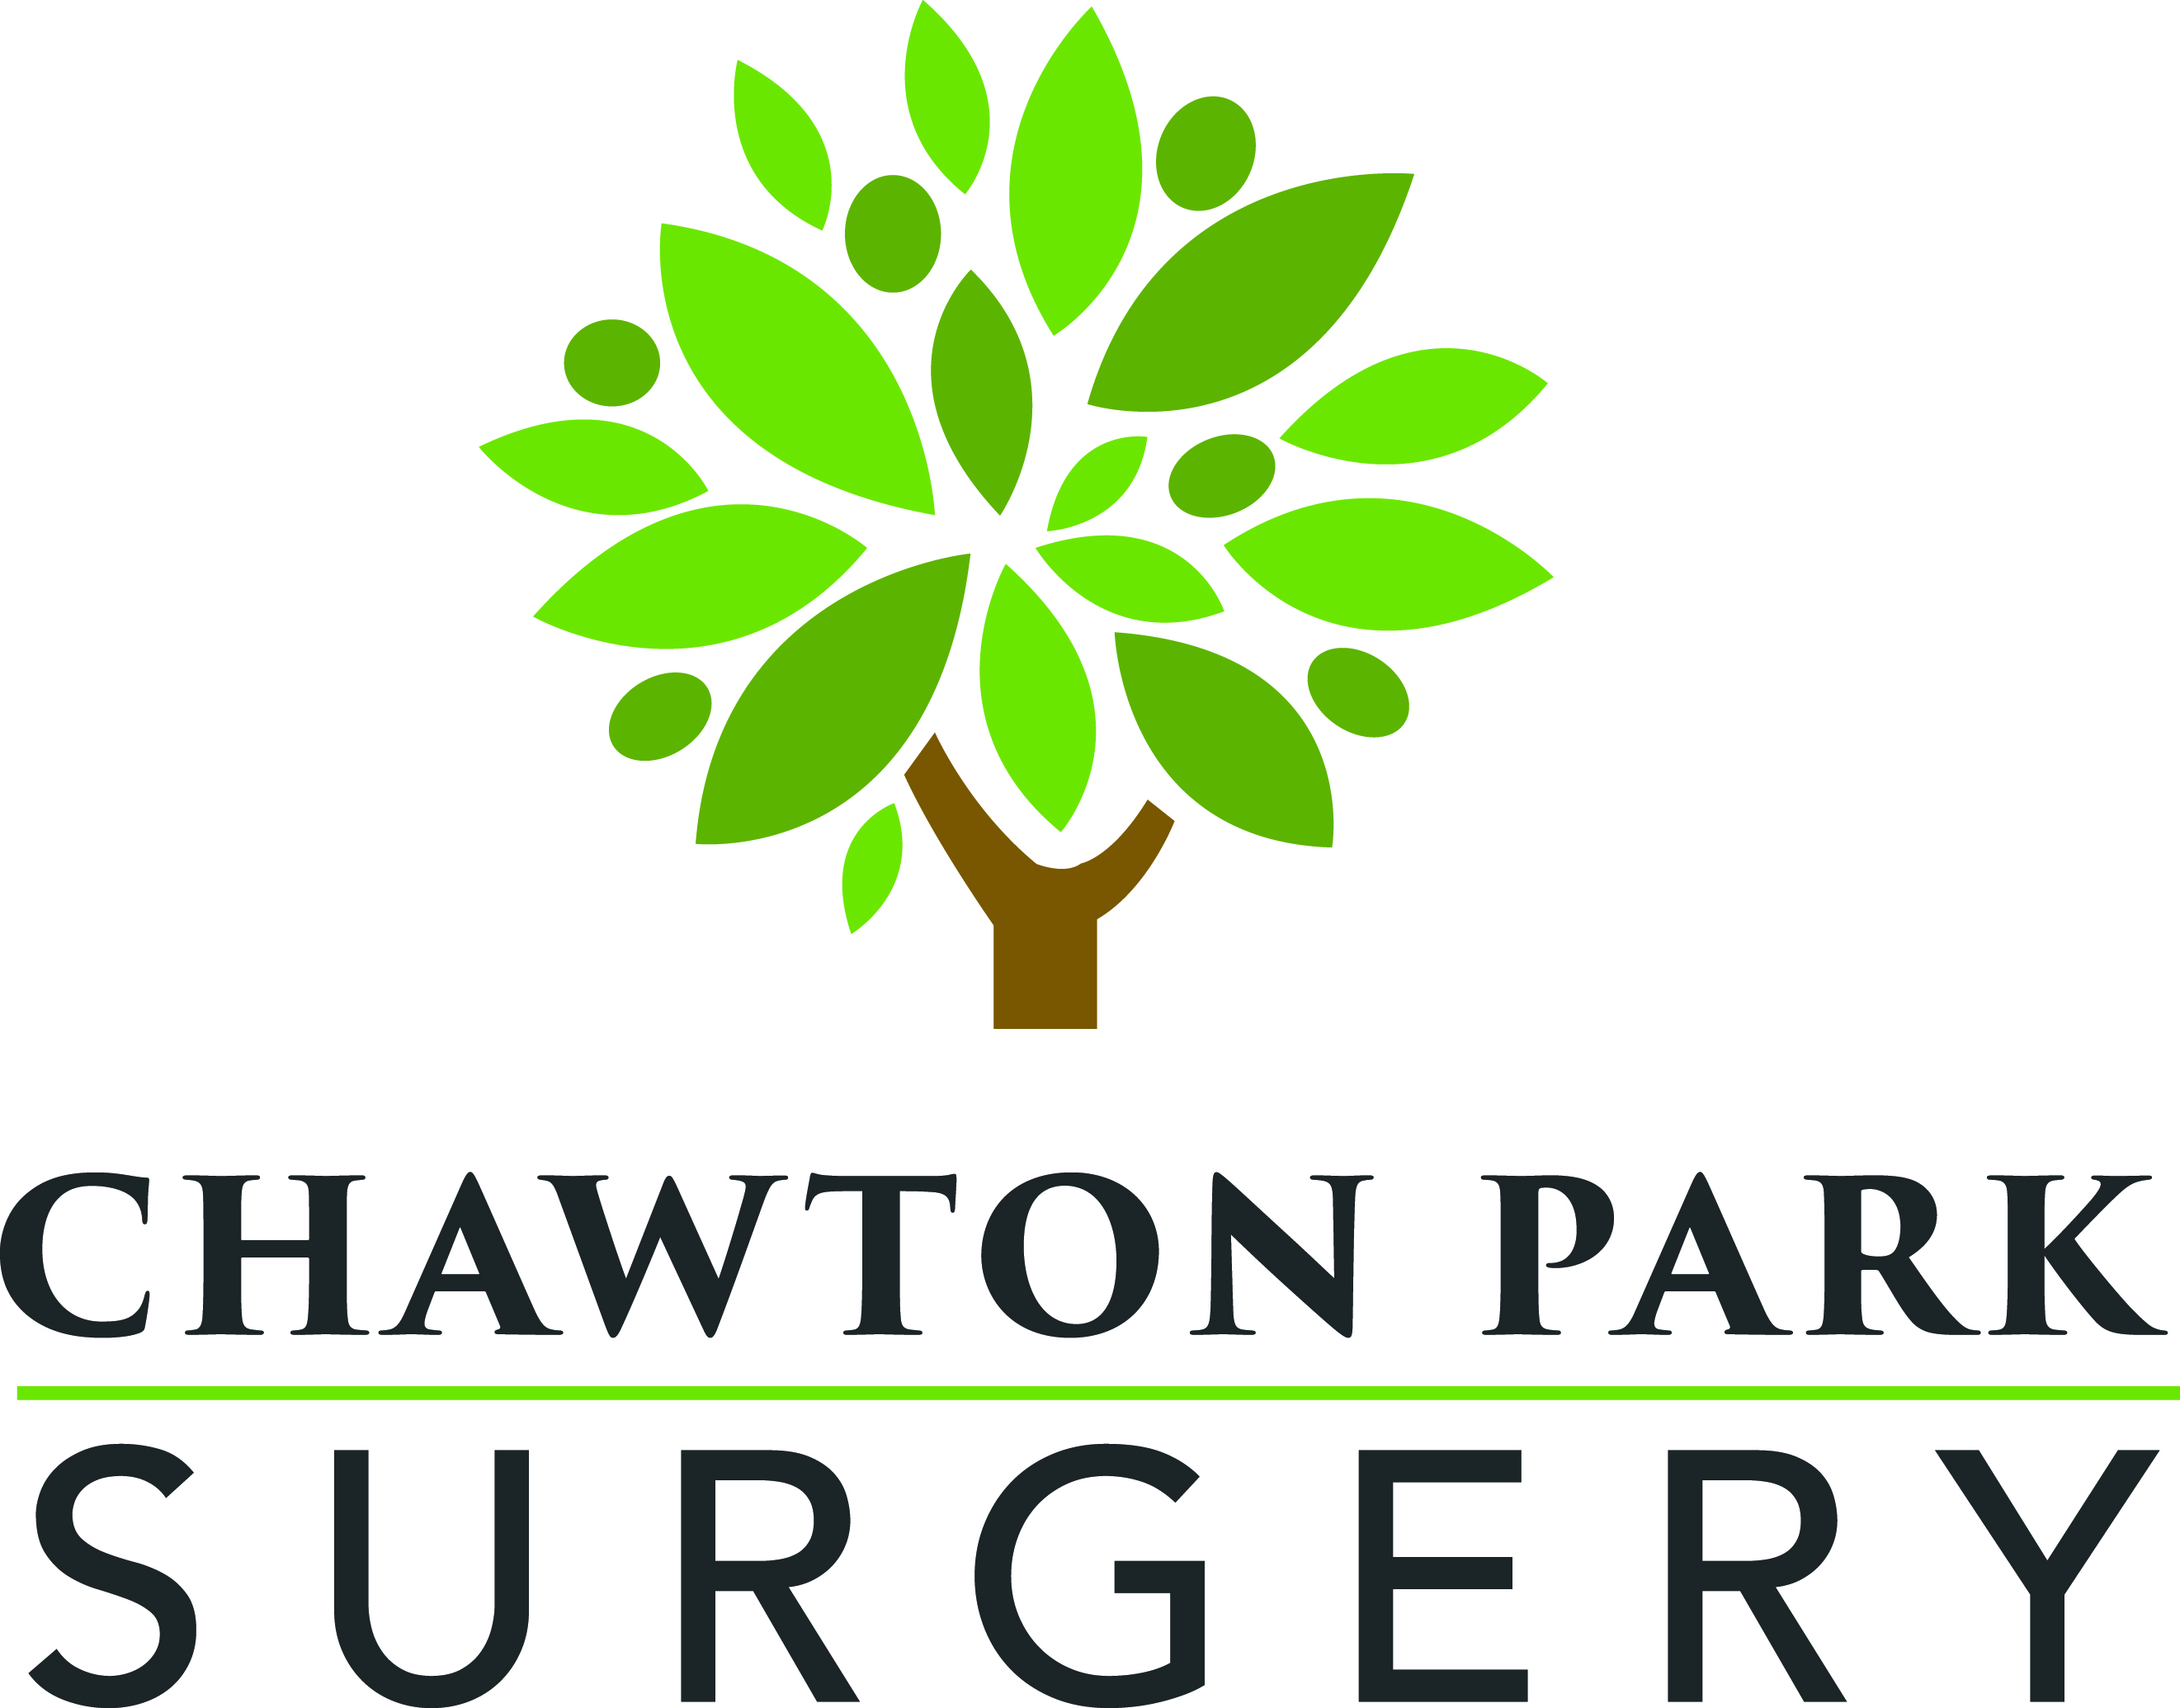

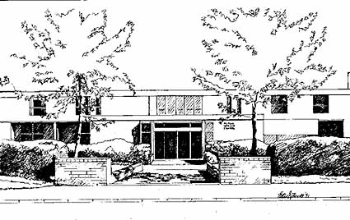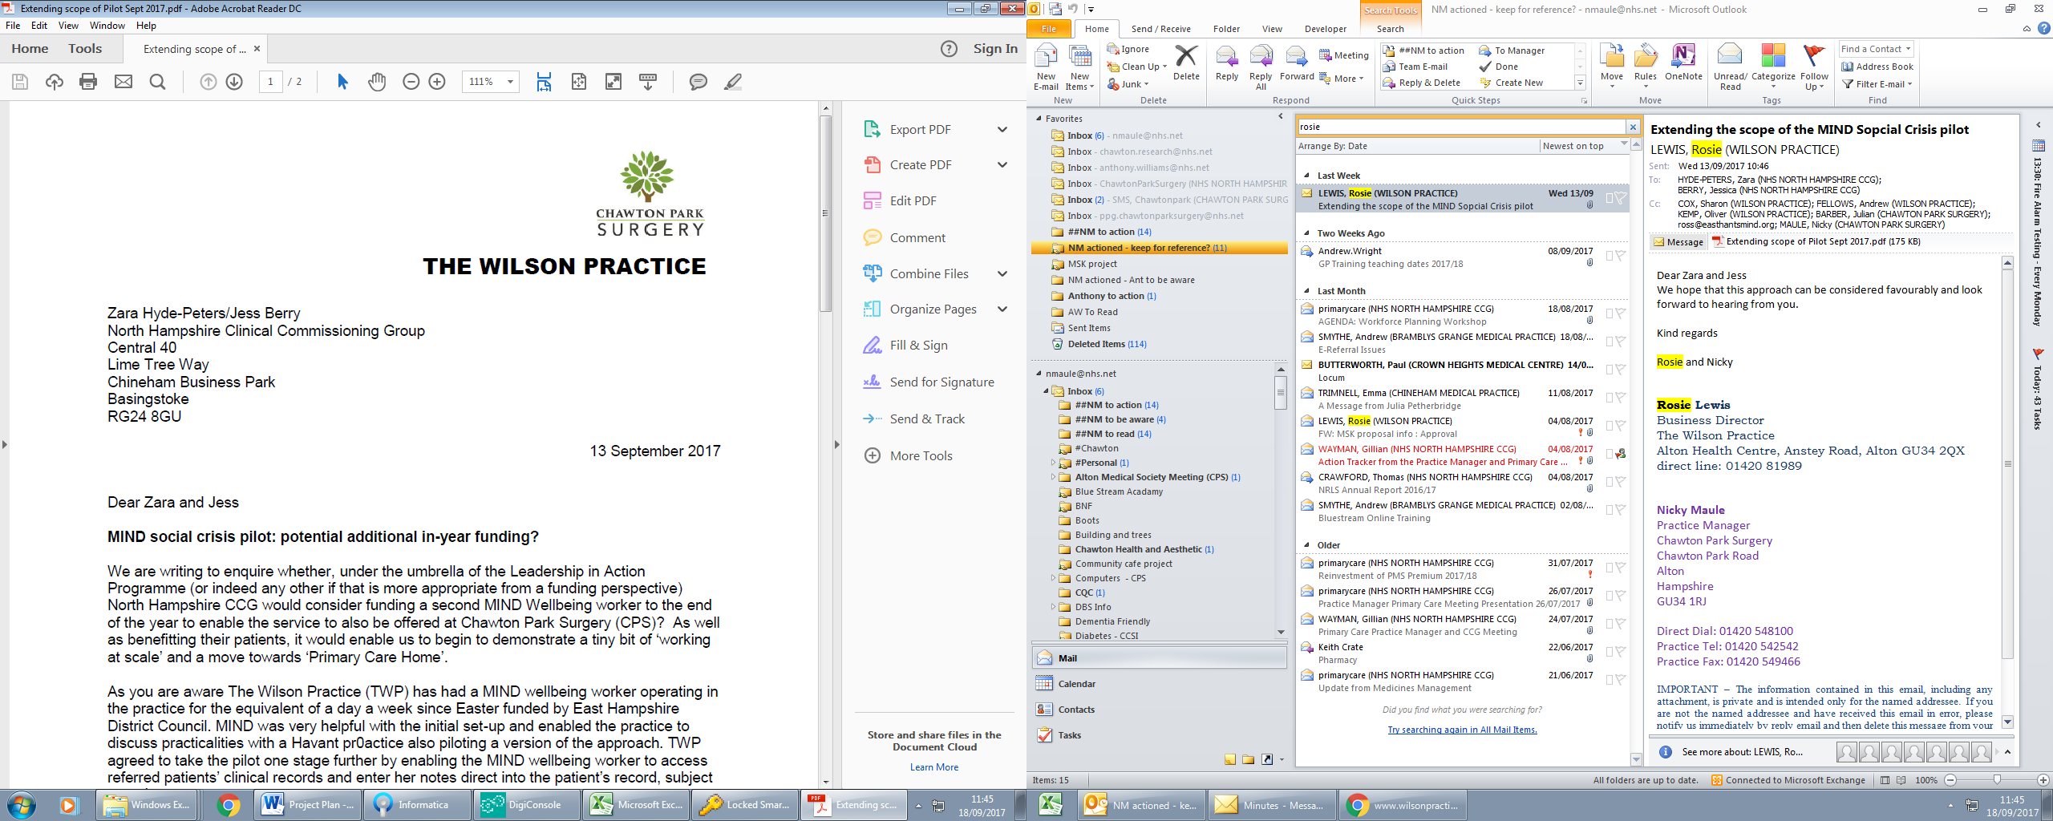



**Bentley Village Surgery**

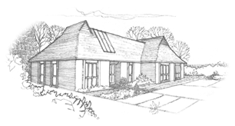

**Boundaries Surgery**

**A31**

**Group**

**of Practices**

**New Initiative to improve access to routine appointments**

We are working with Boundaries Surgery in Four Marks, Chawton Park Surgery and The Wilson Practice to offer patients access to additional GP and nurse appointments. From the beginning of May it has been possible to book a **routine** appointment with a GP or nurse on weekday evenings until 8:00pm and on Saturday mornings from 8:00am – 10:00am.

To access these appointments you can either speak to a member of our reception team by popping into the practice or calling on 01420 22106 just as you would do with a regular day-time appointment.

If available, you will be offered an appointment at either Chawton Park Surgery or the Alton Health Centre.

These surgeries are staffed by doctors, nurses and healthcare assistants from across the **A31 Group of Practices**. You will be asked for your consent before an appointment is made with a clinician who does not routinely work for Bentley Village Surgery; if you provide consent it will enable that person to see your medical records and enter the details of your consultation into them.

It is not currently possible to book these appointments on line because of the need to register consent.